O ct 30, 2025

SUKMA ARIF WIBOWO SUKMA

has successfully completed

Exploratory Data Analysis for Machine Learning

an online non-credit course authorized by IBM and offered through Coursera

Joseph Santarcangelo Senior Data Scientist IBM
Svitlana Kramar
Data Science Content Developer Skills Network




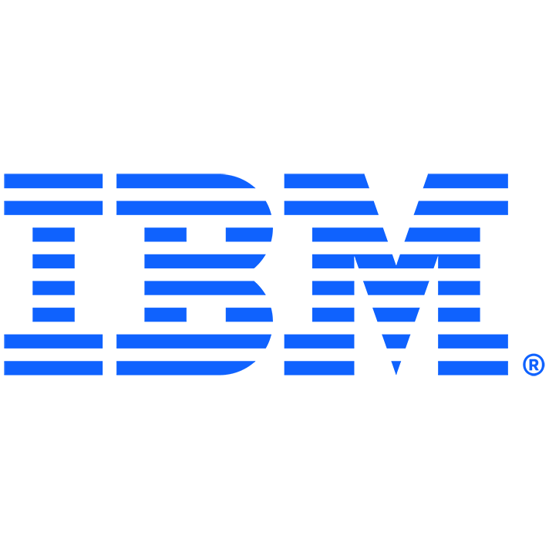



V er i fy at: https://cour ser a.or g /v er if y /3L1F2NPBXA2J
C ou r ser a h as con f ir med th e id en tity of th is in d iv id u al an d
th eir p ar ticip ation in th e cou r se.

